**ROHINI STORE DATA ANALYSIS**

**OBJECTIVE: --- -**

**ROHINI store wants to create an annual sales report for2022. So that, ROHINI can understand their customers and grow more sales in 2023.**

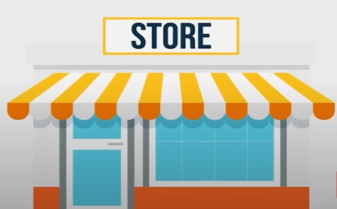

**Sample Insights: ---**

• **Women are more likely to buy compared to men (~65%)**

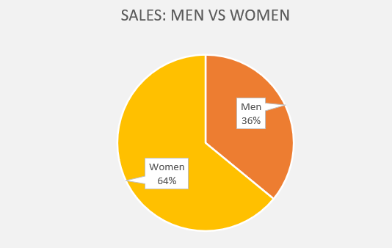

**• Maharashtra, Karnataka and Uttar Pradesh are the top 3 states (~35%**

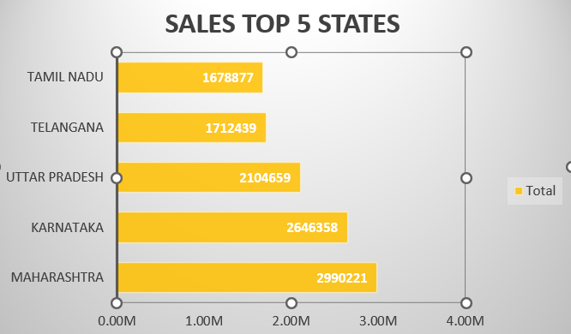

**• Adult age group (30-49 yrs) is max contributing (~50%)**

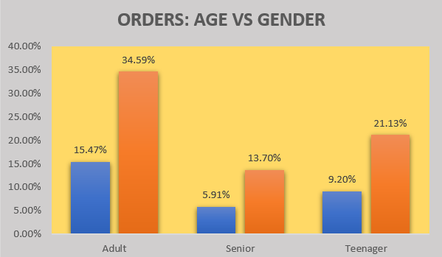

**• Amazon, Flipkart and Myntra channels are max contributing (~80%)**

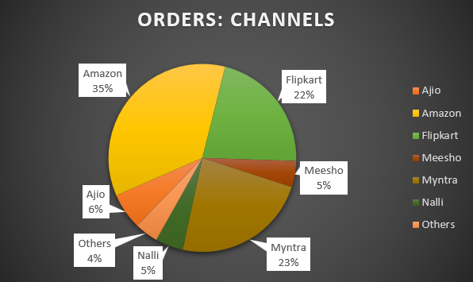

**Final Conclusion to improve ROHINI store sales: ---**

Target women customers of age group (30-49 yrs) living in Maharashtra, Karnataka and Uttar Pradesh by showing ads/offers/coupons available on Amazon, Flipkart and Myntra.

